**Checking entities of cart page.**

Step 1: Navigate to swag labs site using the URL - <https://www.saucedemo.com/>

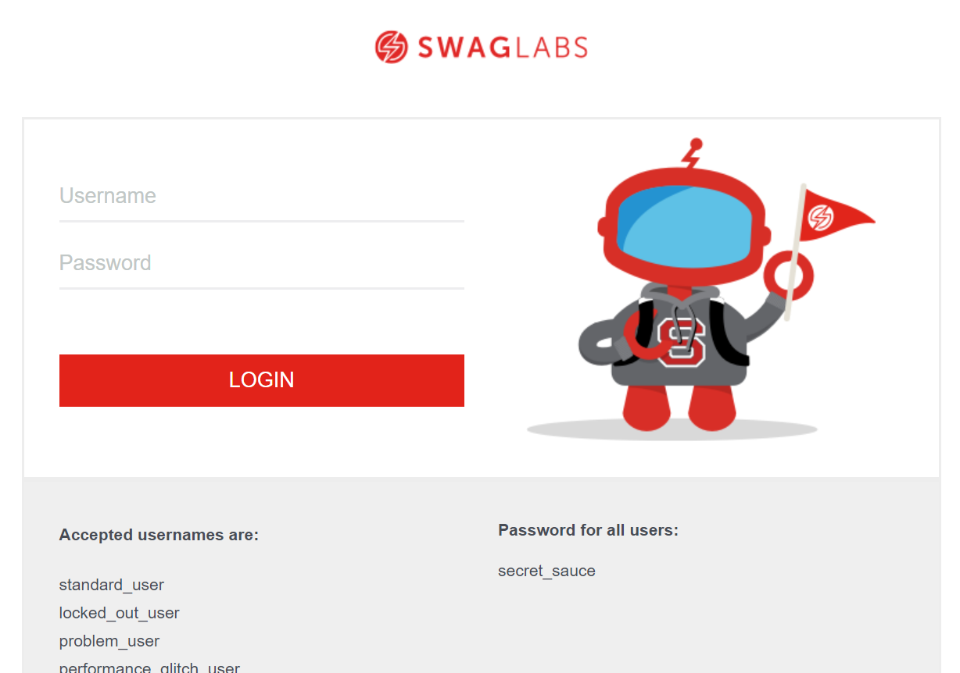

Step 2: Provide valid username and password and click login button. Given: Username= standard_user

Password= secret_sauce

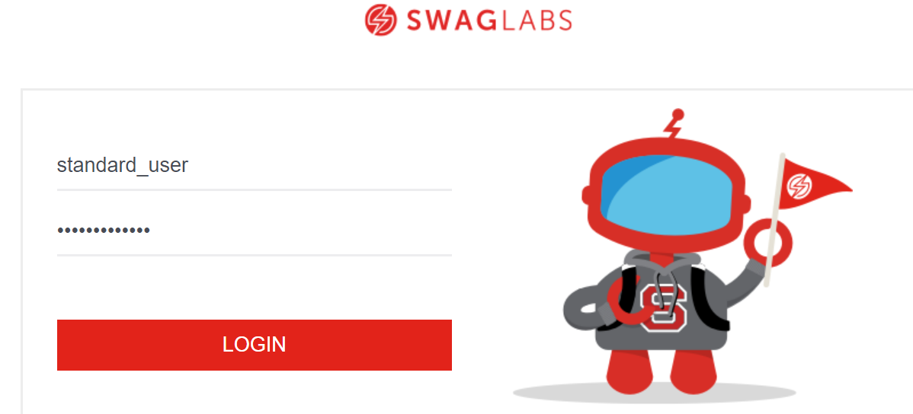

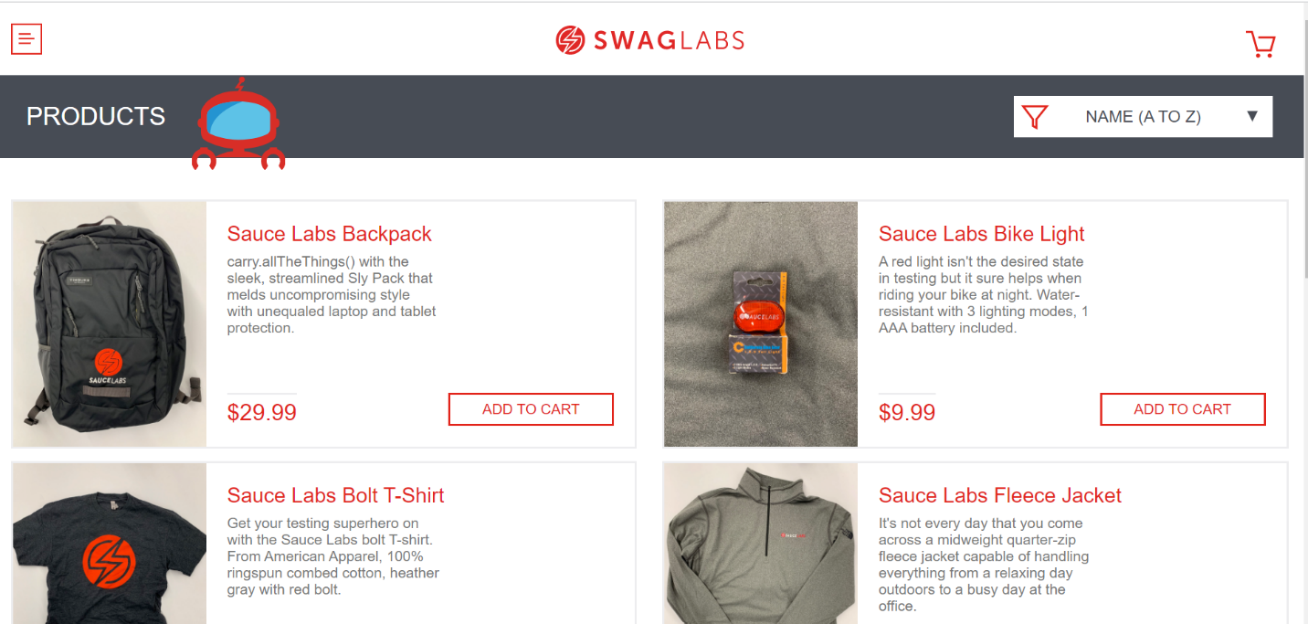

Step 3: Navigate to cart page by clicking cart symbol.

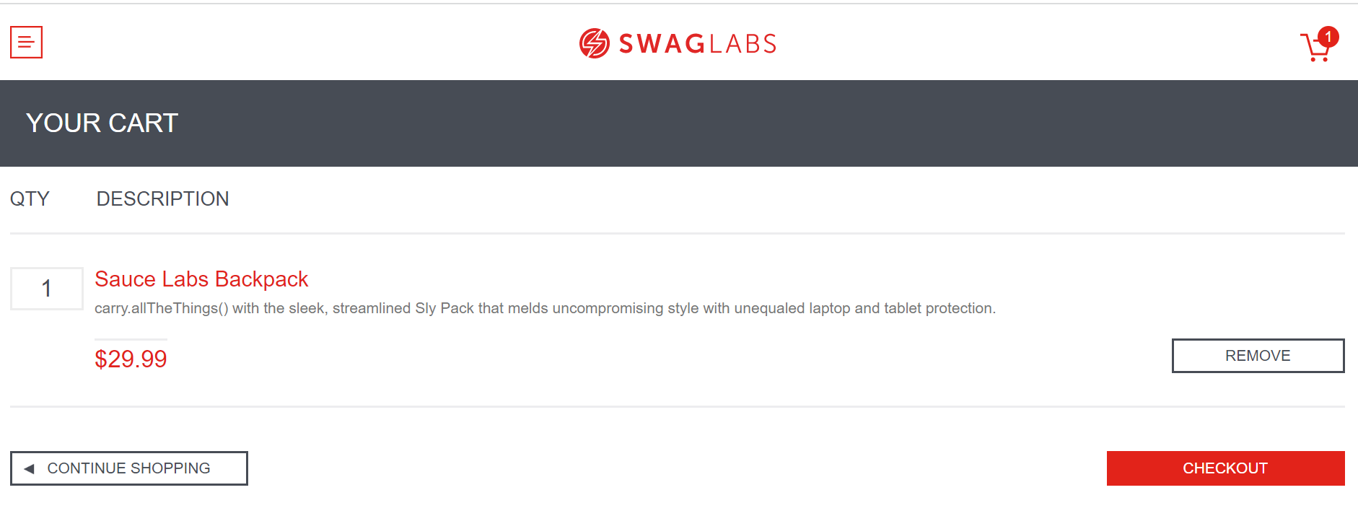

Step 4: Cart page should have below entities:

1. Quantity

2. DESCRIPTION

3. REMOVE button

4. CHECKOUT button

5. CONTINUE SHOPPING button

